

SOFTWARE REQUIREMENTS
SPECIFICATION (SRS)
for
ADVANCED LANGUAGE DETECTION USING CONVOLUTIONAL NEURAL NETWORKS FOR ACCURATE MULTILINGUAL TEXT ANALYSIS
Version 1.0
Prepared by

S. No | Roll Number | Student Name
1. | 22N31A66H8 | U Aravind
2. | 22N31A66D5 | OMV Sandeep
3. | 22N31A66F2 | R Bhanu Prasad

Supervisor: | Dr. Balasani Venkata Ramudu
Designation: | Associate Professor
Department: | Computational Intelligence
Batch ID: | 22CIAD2C23
Date: | 15-03-2025
Supervisor Sign. & Date

Department of Computational Intelligence

Title of the Project: ADVANCED LANGUAGE DETECTION USING CONVOLUTIONAL NEURAL NETWORKS FOR ACCURATE MULTILINGUAL TEXT ANALYSIS

Contents

Contents Ii
Revisions Iii
1 Introduction 1
1.1 Document Purpose 1
1.2 ProJECt Scope 1
1.3 Existing Systems 2
1.4 Problems with Existing Systems 2
1.5 Proposed Systems 3
1.6 Advantages of Proposed Systems 5
2 Overall Description 6
2.1 Feasibility Study 6
2.2 Product Functionality 7
2.3 Design and Implementation Constraints 8
2.4 Assumptions and Dependencies 9
3 Functional Requirements 10
3.1 Software Requirement Specifications 10
3.2 Hardware Requirements Specifications 10
3.3 Use Case Model 10
4 Other Non-functional Requirements 13
4.1 Performance Requirements 13
4.2 Safety and Security Requirements 13
4.3 Software Quality Attributes 14
5 Other Requirements 16
5.1 Database Requirements..................................................................................................................16
5.2 Internationalization Requirements............................................................................................16
5.3 Legal Requirements........................................................................................................................16
5.4 Reuse Objectives...............................................................................................................................17
5.5 Development Environment Requirements...................................................................................17
5.6 Documentation Requirements.......................................................................................................17

6 REFERENCES 18

Revisions

Version | Primary Author(s) | Description of Version | Date Completed
1.0 | George Orwell | Primary Revision giving an overall view of the project and document. | 24/02/25

Introduction

Language detection is a vital component in natural language processing (NLP), enabling systems to automatically identify the language of input text. This capability is critical for applications like multilingual content processing, machine translation, and global communication platforms. Traditional language detection systems often rely on statistical models, rule-based approaches, or n-gram analysis, which perform well for commonly spoken languages with substantial datasets. However, these methods face significant challenges when dealing with short, noisy, or ambiguous text inputs, where contextual cues are minimal.
The rapid expansion of digital content in diverse languages necessitates more sophisticated techniques that can generalize effectively across different linguistic patterns. Recent advancements in deep learning have shown promise, particularly Convolutional Neural Networks (CNNs), known for their ability to capture local patterns in structured data like text. By leveraging CNNs, we aim to address the limitations of existing systems and enhance detection accuracy for challenging scenarios. This approach combines advanced pre-processing techniques and state-of-the-art deep learning frameworks like TensorFlow and Keras to develop a robust, scalable, and real-time language detection solution.

Document Purpose
This Software Requirements Specification (SRS) document outlines the requirements for the "CNN-Based Language Detection System," a system designed to automatically identify the language of a given text with high accuracy, particularly for short and ambiguous inputs. This document specifically details the software requirements for version 1.0 of the project.
The scope of this SRS encompasses text preprocessing, feature extraction, deep learning-based classification, and model evaluation. It focuses on the software aspects of the project, including the implementation of Convolutional Neural Networks (CNNs) for language detection, data preprocessing techniques for noise reduction, and integration with machine learning frameworks such as TensorFlow and Keras. The document does not cover hardware specifications, third-party API integrations, or dataset licensing, which are considered outside the scope. The objective is to provide a clear and comprehensive understanding of the software functionalities required to develop an efficient and scalable AI-driven language detection system.

Project/Product Scope

The CNN-Based Language Detection System is designed to provide an accurate and scalable solution for automatically identifying the language of text-based inputs. This platform leverages Convolutional Neural Networks (CNNs) to analyze linguistic patterns, improving detection accuracy, particularly for short, noisy, or ambiguous text samples. By utilizing deep learning techniques, the system enhances real-time language identification for various applications, including multilingual content processing, search engines, and automated translation services.
The core objectives of the system include:
- Improving language detection accuracy by leveraging CNNs to capture text patterns effectively.
- Supporting multiple languages, including low-resource and closely related languages, for broader accessibility.
- Enhancing performance on short and ambiguous texts, where traditional methods struggle.
- Reducing reliance on rule-based or statistical approaches, making detection more adaptable to real-world data.
- Integrating seamlessly with NLP applications, such as machine translation, chatbots, and content moderation systems.

Existing System
- IBM Watson Language Translator: Identifies source language and offers customizable models for multilingual applications.
- TextRazor API: Provides detailed language detection and metadata, ideal for text mining and content categorization.
- Langid.py: An open-source, offline tool supporting 97 languages for quick and efficient classification.
- Detect Language API: Specialized in robust language detection for short and noisy text with confidence scores.
- Aylien Text Analysis API: Detects over 40 languages as part of scalable text analysis and insight extraction tools.
- DeepL Translator: High-quality language detection with neural networks, integrated into translation services.

Problems with Existing System

- Limited Accuracy for Short Texts – Traditional language detection methods struggle with short phrases or single words, as they lack sufficient context for accurate classification. CNN-based models improve this by capturing character-level and sub word patterns to infer language effectively.
- Sensitivity to Noise – Text inputs often contain typos, slang, or mixed-language content, which can confuse rule-based and statistical models. Deep learning techniques help mitigate this by learning robust patterns, but noise still affects prediction reliability.
- Low Support for Rare Languages – Many existing models are trained on high-resource languages, leading to poor performance on lesser-known or low-resource languages. Expanding datasets and fine-tuning CNN models can enhance recognition for such languages.
- Dependency on Large Datasets – CNN-based models require vast amounts of labeled text data to achieve high accuracy. This dependency increases computational costs and limits effectiveness in domains where sufficient training data is unavailable.

Proposed System

- Convolutional Neural Networks (CNNs) – CNNs are used to detect local text patterns by applying convolutional filters over character sequences. This allows the model to learn distinctive language structures, improving accuracy for short and ambiguous texts. Their ability to recognize n-gram-like patterns makes them effective for multilingual detection.
- Deep Learning Frameworks – The system is built using TensorFlow and Keras, which provide efficient tools for deep learning model development and training. These frameworks offer pre-built layers, optimizers, and loss functions, enabling faster experimentation and fine-tuning. GPU support further enhances training speed and performance.
- Data Preprocessing – Raw text data undergoes cleaning, tokenization, and sequence padding to ensure consistency before feeding it into the model. Cleaning removes unwanted symbols and noise, tokenization breaks text into meaningful units, and padding standardizes input length. These steps improve the model's ability to generalize across different languages and text styles.
- Short and Ambiguous Text Handling – Traditional models struggle with brief text inputs, which provide minimal linguistic context. The CNN-based approach leverages subword and character-level features to identify language patterns more effectively. By learning contextual relationships, the system enhances accuracy in noisy or incomplete inputs.
- Semantic Feature Learning – The model incorporates embedding layers that transform text into dense vector representations, capturing semantic similarities between words and characters. These embeddings help the CNN detect linguistic structures more effectively across different languages. Pretrained embeddings or fine-tuned representations improve generalization.
- Real-Time Deployment – The system is designed for scalable real-time inference using APIs built with Flask or FastAPI. These frameworks enable seamless integration with web applications, chatbots, and translation tools. Optimized deployment ensures fast processing, making language detection accessible for various real-world applications.

Advantages of Proposed Systems

- Improved Accuracy for Short and Noisy Texts – Unlike traditional rule-based and statistical models, CNNs capture local text patterns, enhancing accuracy even for short and ambiguous inputs.
- Robust Handling of Multilingual Data – The system effectively detects multiple languages, including low-resource ones, by learning meaningful character-level and word-level features.
- Real-Time Processing – Optimized model inference and API deployment using Flask or FastAPI ensure fast and efficient language detection for live applications.
- Scalability and Integration – The system can be easily integrated into various applications, such as search engines, chatbots, and content moderation tools, through API-based deployment.
- Reduced Dependency on Handcrafted Features – Traditional methods require manual linguistic rules, whereas CNN-based learning automatically extracts key language patterns, reducing human effort.

Overall Description

Feasibility Study
A feasibility study was conducted to evaluate the viability of the CNN-Based Language Detection System, focusing on technical, economic, operational, and scheduling aspects.
- Technical Feasibility: The system utilizes established deep learning frameworks like TensorFlow and Keras for model training and inference. Real-time text analysis is enabled through optimized APIs using Flask or FastAPI, ensuring seamless deployment across platforms. Scalability is ensured through modular design, allowing easy model updates and improvements.
- Economic Feasibility: The system relies on open-source AI libraries, reducing development costs. It can be integrated into existing applications, offering monetization opportunities through API licensing and enterprise solutions.
- Operational Feasibility: Designed for ease of use, the system provides real-time language detection with minimal manual intervention. The API-based architecture enables smooth integration with search engines, chatbots, and content moderation tools.
- Scheduling Feasibility: The project follows a structured development timeline, including phases for dataset collection, model training, optimization, and deployment. Risk management strategies address potential challenges such as handling low-resource languages and noise in input text.
The feasibility study confirms that the system is technically, economically, and operationally viable, providing an efficient and scalable solution for language detection.

Product Functionality
The CNN-Based Language Detection System offers key functionalities to enable accurate and real-time text classification:
- Real-Time Text Processing: Captures and analyzes input text, applying preprocessing techniques like tokenization and sequence padding.
- Deep Learning-Based Classification: Uses CNNs trained on multilingual datasets to detect languages with high accuracy.
- Noise-Resistant Detection: Enhances recognition of short or ambiguous text, improving performance in chat applications and search engines.
- Scalability & Integration: Deployable as an API for seamless integration into various platforms like social media, content moderation systems, and real-time messaging apps.
- Multilingual Support: Detects multiple languages, including low-resource ones, ensuring broad applicability.

Design and Implementation Constraints

The development of the CNN-Based Language Detection System must adhere to several key constraints:
- Hardware & Performance Limitations
  - The system should efficiently process text in real-time without requiring high-end hardware.
  - Optimization techniques like model quantization and batch processing should be implemented to enhance speed and efficiency.
- Software Platform
  - The project will be developed using Python with deep learning frameworks such as TensorFlow and Keras.
  - The system should be platform-independent, ensuring compatibility with Windows, Linux, and cloud environments.
- Scalability & Flexibility
  - The architecture should support easy updates to the language model and preprocessing pipeline.
  - The system should be extendable to support additional languages and dialects without major modifications.
- User Interface (UI) and Accessibility
  - A simple and interactive GUI (if applicable) should be designed for ease of use by non-technical users.
  - API-based access should be available for integration with third-party applications and web services.
- Data Handling & Storage
  - The system should efficiently manage large text datasets, ensuring fast retrieval and minimal memory overhead.
  - Logs and performance reports should be maintained for monitoring accuracy and improving model performance.
- Security & Privacy
  - Sensitive text data should be encrypted during storage and transmission to prevent unauthorized access.
  - The system must comply with data privacy laws (e.g., GDPR) and ensure responsible AI usage.
- Industry Standards & Compliance
  - The model should adhere to standard NLP encoding formats (UTF-8) and text preprocessing conventions.
  - The system must incorporate bias mitigation techniques to ensure fair and unbiased language classification.

Assumptions and Dependencies

The following assumptions and dependencies are critical to the successful development and implementation of the CNN-Based Language Detection System:
Assumptions
- User Proficiency in Basic System Usage: Users are expected to have a general understanding of text input and basic system operations.
- Availability of Labeled Datasets: The system assumes access to high-quality, pre-labeled multilingual datasets for training and evaluation.
- Stable AI Frameworks: It is assumed that deep learning libraries such as TensorFlow, Keras, and Scikit-learn will continue to receive updates and support.
- Scalability of Model Training: The system assumes that computational resources (local or cloud-based) will be sufficient to train and fine-tune the CNN model efficiently.
- Language Support Demand: The system assumes a growing need for automated language detection in applications like content moderation, translation services, and security monitoring.
Dependencies
- AI Framework and Library Support: The platform depends on stable versions of TensorFlow, Keras, and NumPy for model development and deployment.
- Preprocessing and Feature Extraction Tools: The system relies on NLP libraries like NLTK and spacy for text preprocessing tasks such as tokenization and stop word removal.
- Third-Party APIs: If external APIs (e.g., Google Translate, OpenAI language models) are integrated, any changes in their availability or pricing models may impact the system.
- Compliance with Data Privacy Regulations: The system must adhere to data protection standards (e.g., GDPR, ISO 27001) when handling sensitive text data.
- Hardware Limitations: Performance and speed depend on the availability of GPU acceleration or cloud-based processing for handling large datasets and real-time detection.
Conclusion
The CNN-Based Language Detection System is built on a robust AI-driven architecture designed for efficiency, scalability, and accuracy. By addressing these assumptions and dependencies, the system ensures reliable performance for real-world applications in multilingual content processing and security monitoring.

Functional Requirements

Software Requirement Specifications
The CNN-Based Language Detection System requires the following software components:
- Operating System: Windows 10/11, macOS, or Linux (Ubuntu preferred)
- Programming Language: Python 3.x
- Deep Learning Frameworks: TensorFlow, Keras
- Web Framework: Flask/FastAPI (for API and UI-based monitoring)
- Data Processing Libraries: spaCy, NumPy, Pandas
- Version Control System: Git/GitHub

Hardware Requirements Specifications

The system’s AI-based language detection model requires:
- Processor: Intel Core i5/i7 or AMD Ryzen 5/7 (or higher)
- RAM: Minimum 8GB (16GB recommended for training larger datasets)
- Storage: 250GB SSD (512GB+ preferred for extensive language models)
- GPU: NVIDIA GTX 1650 or higher (for efficient model training and inference)
- Internet: Stable connection required for cloud-based model training and API integration

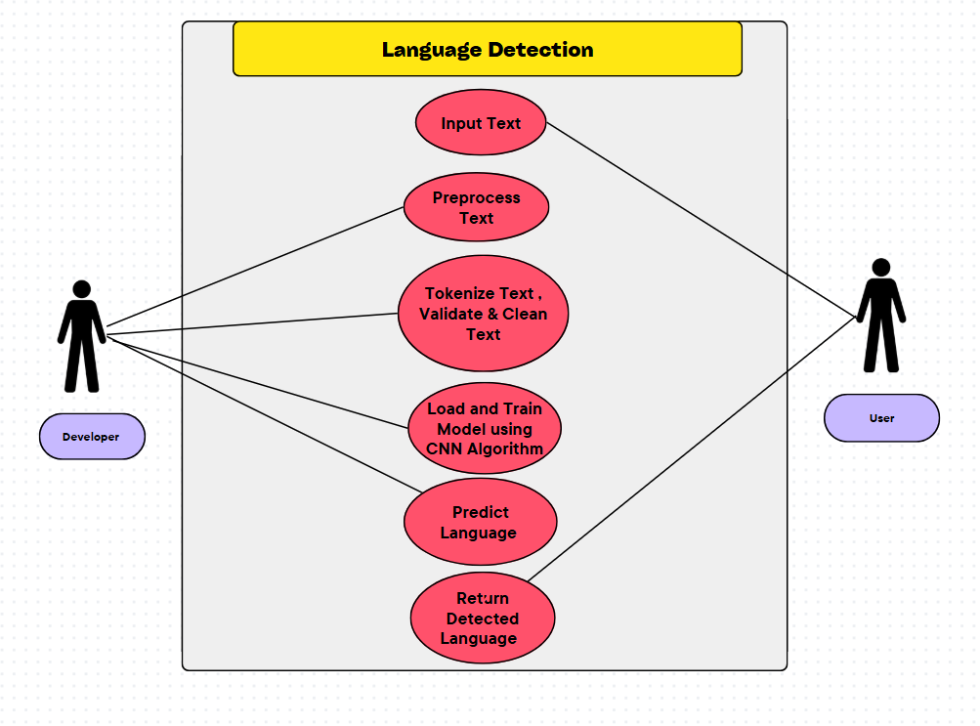
Use Case Model
Fig 1. Use case diagram

3.3.1 Use Case #1
The diagram represents a CNN-Based Language Detection System, illustrating the interaction between a Developer and a User within the system.
Key Components of the Diagram:
Actors:
  - Developer (Left): Responsible for building, training, and deploying the CNN model for language detection.
  - User (Right): Interacts with the system to input text and receive language predictions.
Processes in the Language Detection System:
  - Input Text – The user provides raw text that needs to be analysed.
  - Preprocess Text – The system cleans and standardizes the input text, removing unwanted characters or noise.
  - Tokenize, Validate & Clean Text – The text is tokenized, validated, and further refined for consistency.
  - Load and Train Model using CNN Algorithm – The system loads and trains a Convolutional Neural Network (CNN) to identify language patterns.
  - Predict Language – The trained model processes the input and predicts the language.
  - Return Detected Language – The final prediction is displayed to the user.

Data Flow Diagram

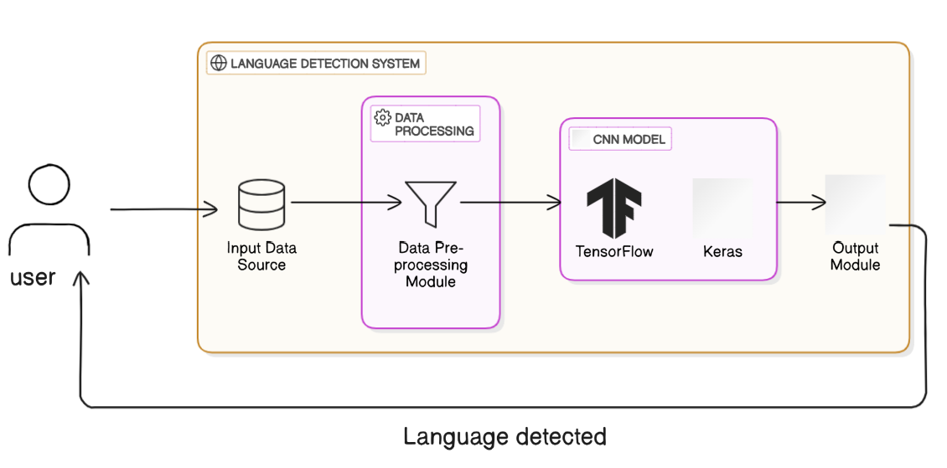
Fig 2.Data flow diagram

Other Non-functional Requirements
To ensure accurate and efficient language detection using CNNs, the system must meet the following performance requirements:
P1. Text Processing Speed
  - The system must preprocess and tokenize input text within 2 seconds, ensuring smooth pipeline execution.
P2. Language Prediction Time
  - The CNN-based model should detect the language in under 1 second for short texts (≤100 words) and ≤3 seconds for longer inputs.
P3. Accuracy of Language Detection
  - The model should achieve ≥95% accuracy for common languages and ≥85% accuracy for rare or low-resource languages.
P4. Noise Resilience
  - The system must handle noisy or misspelled text with minimal accuracy drop (<5%), improving robustness against input variations.
P5. Model Training Efficiency
  - CNN model training should complete within 2 hours on a system with NVIDIA RTX 3060 (or higher) for datasets up to 1M text samples.
P6. Scalability & Cloud Processing
  - The system must support real-time processing for multiple concurrent requests via cloud-based deployment (AWS, Google Cloud).
P7. Storage Optimization
  - The trained CNN model and embeddings should be optimized to occupy ≤500MB, ensuring fast loading and minimal memory usage.
P8. UI & API Responsiveness
  - The web-based UI and API endpoints must respond within 0.5 seconds, ensuring an interactive experience for users.
P9. Multilingual Support
  - The model should support at least 50 languages, covering diverse linguistic families and scripts.

P10. Continuous Model Improvement
The system should support incremental learning to adapt to new linguistic patterns and improve accuracy over time.

Safety and Security Requirements

S1. Data Integrity
- Ensure that input text data remains unaltered during processing.
- Implement hashing mechanisms (SHA-256) for content verification.
S2. Protection Against Malicious Code
- Sanitize user inputs to prevent adversarial attacks that could mislead the CNN model.
- Regularly scan AI libraries (TensorFlow/PyTorch) for vulnerabilities.
- Prevent injection-based exploits in Flask/Django APIs.
S3. Secure File Handling
- Validate text file formats (UTF-8 encoding) before processing.
- Implement rate-limiting on file uploads to prevent DoS attacks.
S4. Secure API Usage
- OAuth 2.0 and JWT tokens should be used for authentication when accessing external AI services (Hugging Face, OpenAI).
- Prevent unauthorized API access by enforcing access control policies.
S5. Encrypted Data Transmission
- Use SSL/TLS encryption to secure text data transmission between user and server.
- Ensure database encryption (AES-256) for stored language detection results.
S6. Access Control
- Implement Role-Based Access Control (RBAC) to ensure only authorized users can access model training and prediction functions.
- Protect CNN model weights and training datasets from unauthorized modifications.
S7. User Content Privacy
- Ensure compliance with copyright laws when processing text data.
- Provide options for text anonymization before AI processing.

S8. No Collection of Personal Data
- Avoid storing identifiable text data unless explicitly required.
- Ensure compliance with GDPR/CCPA for language-based content processing.
S9. Software Updates & Security Patching
- Regularly update CNN model parameters and retrain with latest datasets to mitigate biases and vulnerabilities.
- Use Docker image signing to prevent tampering with AI models.
S10. Error Handling & Logging
- Implement robust logging mechanisms for tracking errors in text preprocessing, tokenization, CNN model execution, and predictions.
- Prevent information leakage in error messages that could expose system internals.

Software Quality Attributes

The following attributes are critical for ensuring the platform’s usability, maintainability, and scalability.
4.3.1. Usability
Requirement:
- The language detection module must be accurate, fast, and seamless for both developers and end-users.
Implementation:
- Provide an automatic language detection feature when users input text.
- Display detected language in real-time with confidence scores.
- Enable manual override for users to correct or change detected languages if necessary.
- Optimize UI to show detected language before further processing (summarization, translation, video generation).
Verification:
- Conduct user testing to validate accuracy and ease of use.
- Track language detection accuracy metrics (precision, recall, F1-score).
4.3.2. Maintainability
Requirement:
- The CNN-based language detection system must support easy updates and improvements as new languages and models emerge.
Implementation:
- Use a modular approach:
  - Separate tokenization, text preprocessing, and CNN model inference into distinct modules.
- Store language detection logs for debugging and model improvement.
- Maintain version-controlled AI models to support model upgrades without affecting production.
- Provide detailed documentation for:
  - Model architecture
  - Training datasets
  - API endpoints
Verification:
- Conduct model versioning and rollback testing to ensure updates do not degrade performance.
4.3.3 Adaptability (Design for Change)
Requirement:
- The language detection system must support multiple languages, dialects, and evolving AI models.
Implementation:
- Use a transfer learning approach to easily adapt the CNN model for new languages.
- Allow integration of pre-trained multilingual models (e.g., fastText, XLM-RoBERTa) for better accuracy.
- Design API-based language detection services for scalability and compatibility with other AI modules.
Verification:
- Successfully integrate additional languages without requiring major system changes.
- Compare performance before and after adding new language support.

4.3.4 Reliability
Requirement:
- The language detection system must be highly accurate and stable, even with noisy or incomplete text input.
Implementation:
- Implement error handling for cases where language detection confidence is low (e.g., ambiguous or mixed-language input).
- Use fallback mechanisms to detect language using statistical models or rule-based methods if the CNN model fails.
- Ensure continuous model monitoring using real-world text samples.
Verification:
- Evaluate system performance using benchmark datasets and real-world user inputs.
- Measure system uptime and failure rates to assess reliability.

Other Non-functional Requirements

Database Requirements (If Applicable)
- R1. Language Detection Logs: The system should store detected language metadata (e.g., detected language, confidence score, processing time) for analytics and debugging.
- R2. Model Performance Tracking: Maintain logs of CNN model performance, including precision, recall, and F1-score for different language inputs.
- R3. Data Security & Integrity: All stored text inputs must be sanitized and encrypted to prevent data leaks or tampering.

Internationalization Requirements (If Applicable)
- R4. Multilingual Support: The CNN-based language detection must support a wide range of languages and dialects, including non-Latin scripts.
- R5. Adaptive Learning: The system should allow fine-tuning of CNN models to improve performance on underrepresented languages.
- R6. Unicode & Character Support: Ensure UTF-8 encoding to correctly process multilingual text, emojis, and special characters.

5.3 Legal Requirements
- R7. AI Fairness & Bias Mitigation: Language detection must be tested for bias against specific languages, dialects, or minority groups.
- R8. GDPR & Data Privacy Compliance: Ensure that language detection does not store or process personally identifiable information (PII) without user consent.
- R9. Accessibility Support: The detected language should integrate with text-to-speech (TTS) systems to support users with disabilities.

5.4 Reuse Objectives
- R10. Modular AI Components: The CNN-based language detection should be a standalone module that can be reused across different applications (e.g., chatbots, transcription tools).
- R11. API-Based Integration: Provide REST API support so that external applications can call the language detection service.
- R12. Model Reusability: Allow fine-tuned models to be shared and reused across different deployments.

5.5 Development Environment Requirements
- R13. Deep Learning Frameworks: Implement the CNN-based model using TensorFlow/Keras or PyTorch.
- R14. Version Control & CI/CD: Maintain model training scripts and deployment code in GitHub/GitLab with automated versioning.
- R15. AI Model Testing Tools: Use unit testing (pytest, TensorFlow Model Analysis) to validate model accuracy.
- R16. Cloud Deployment & Scalability: Deploy language detection as a microservice (AWS Lambda, GCP Functions) for high availability.

5.6 Documentation Requirements
- R17. Model Documentation: Provide a detailed explanation of CNN architecture, dataset sources, and training methodologies.
- R18. API Documentation: Clearly define API endpoints, request/response formats, and authentication methods.
- R19. User Guide & Tutorials: Include examples of using language detection in real-world scenarios (e.g., automatic translation, voiceover selection).
- R20. Versioning & Release Notes: Maintain version history with updates on model improvements, bug fixes, and newly supported languages.

References

[1]. Brown, P. F., Pietra, V. J. D., Pietra, S. A. D., & Mercer, R. L. (1993). The mathematics of statistical machine translation: Parameter estimation. Computational Linguistics, 19(2), 263-311.
[2]. Koehn, P. (2009). Statistical Machine Translation. Cambridge University Press.
[3]. Mikolov, T., Sutskever, I., Chen, K., Corrado, G. S., & Dean, J. (2013). Distributed representations of words and phrases and their compositionality. Advances in Neural Information Processing Systems, 26.
[4].Zhang, X., Zhao, J., & LeCun, Y. (2015). Character-level convolutional networks for text classification. Advances in Neural Information Processing Systems, 28.
[5]. Vaswani, A., Shazeer, N., Parmar, N., Uszkoreit, J., Jones, L., Gomez, A. N., ... & Polosukhin, I. (2017). Attention is all you need. Advances in Neural Information Processing Systems, 30.

SRS DOCUMENT REVIEW

CERTIFICATION

This Software Requirement Specification (SRS) Document is reviewed and certified to proceed for the project development by the Departmental Review Committee (DRC).
Date of SRS Submitted:

Date of Review:
Supervisor Comments:
Supervisor Sign. & Date.
Coordinator Sign. & Date
HOD Sign. & Date
Dept. Stamp

Guidelines :
- Font Style for the Content Page is ”Times New Roman”.
- Font Style for the Remaining Pages is “Calibri(Body)”.
- Font size for Headings is 14 size
(Example – 4.3 Software Quality Attributes).
- Font size for Sub-Headings is 12 size
(Example – 4.3.1 Usability).
- Headings and Sub-Headings must be in bold letters.
- Font size for the content is 12 size.
- Line Spacing value is 1.15.

